Statistics Lecture 8.6: Hypothesis Testing Involving Variance and Standard Deviation.

Chi-squared
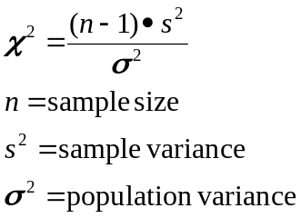

Example
In a sample of 37 coins. The mean weight was 2.49910 grams with a standard deviation of 0.01648 grams.

Test the claim that the populations standard deviation is less than 0.023 grams at a 0.05 significance level.

Step 1 Identify claim and opposite
Claim: 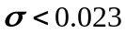
Opposite: 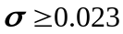

Step 2 Set up Null and alternative Hypothesis.
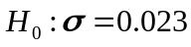
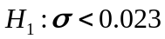

Step 3 Identify Significance Level
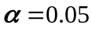 One tail

Step 4 Calculate the Test Statistic
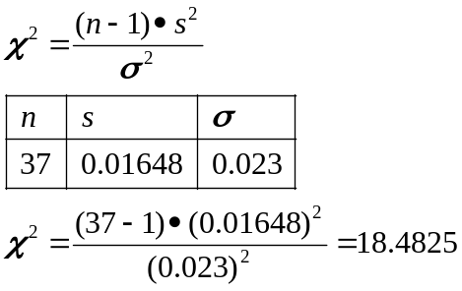

Step 5 Graph

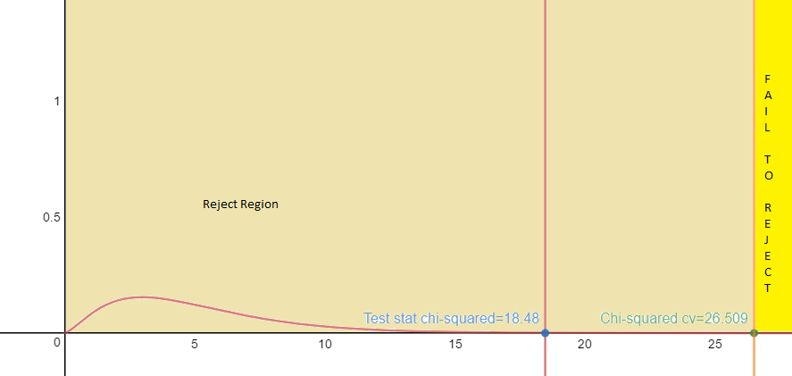

Test statistic 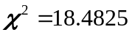
Left tail test

Chi squared Critical value = 26.509 (Degrees Of Freedom used is 40

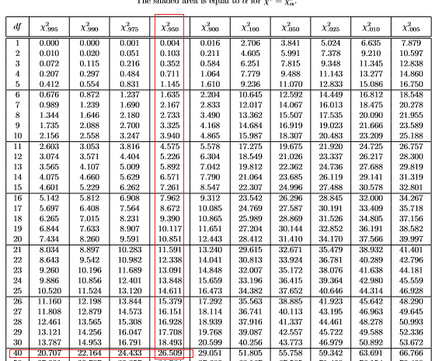

Step 6 Make a decision
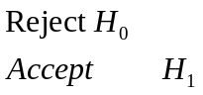
Since the test statistic 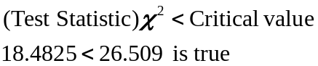

Step 7 Interpret
Reject 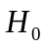 There is enough evidence to support the claim that the populations standard deviation is less than 0.023 gram with a 95% certainty

Step 5 Graph Traditional

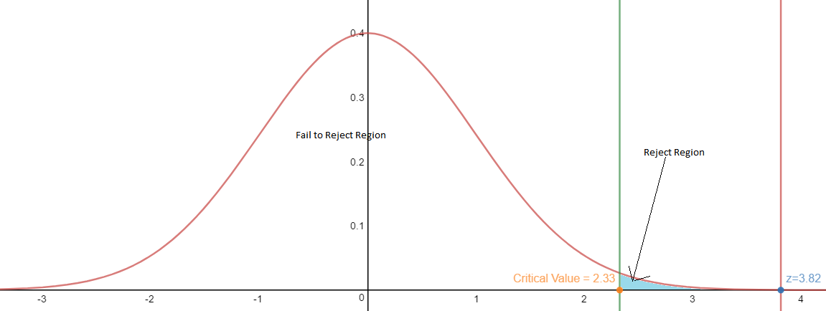

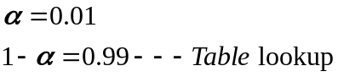 One tail

Critical Value =2.33
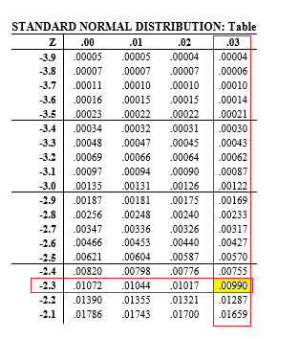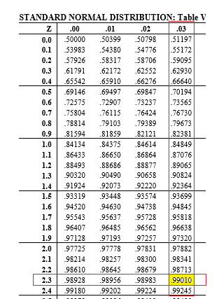

Step 4 Calculate the Test Statistic
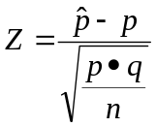
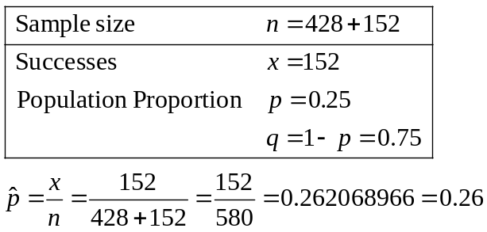

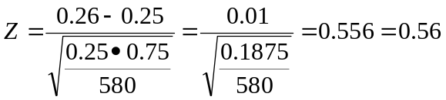
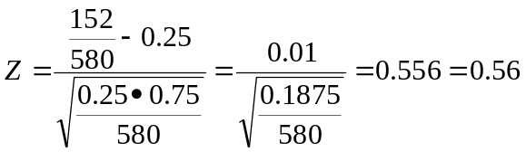

Step 5 graph
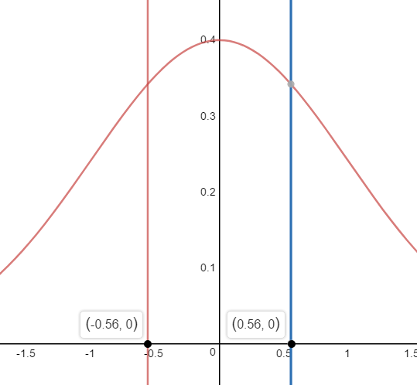
P-value is the area in the tail(s)
Area= 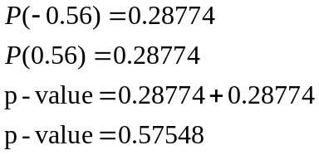

Step 6 Make a decision
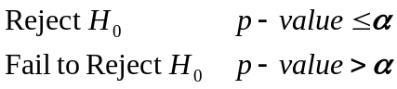
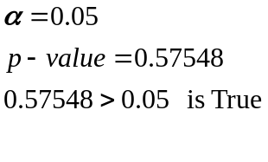
Fail to Reject therefore 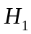 is unknown

Step 7 Interpret
Fail to Reject There is not enough evidence to support the claim that the proportion of yellow pods is equal to 1/4.
Step 5 graph (Tradition Method

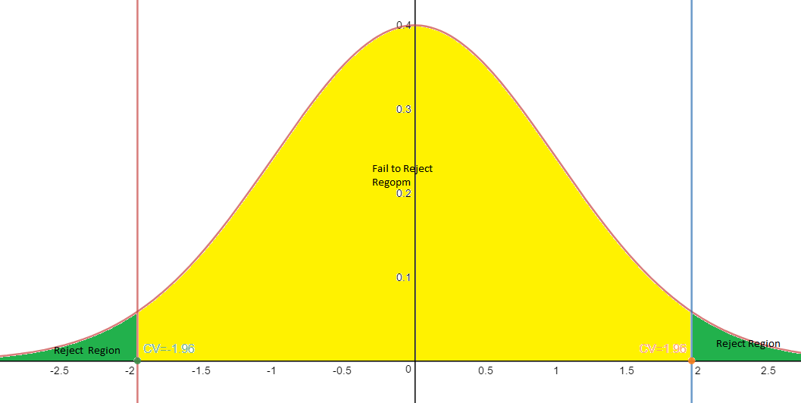
P-value is the area in the tail(s)
Area= 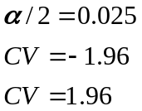

Step 6 Make a decision
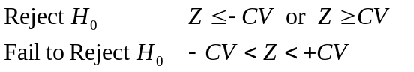

Fail to Reject therefore is unknown

Step 7 Interpret
Fail to Reject There is not enough evidence to support the claim that the proportion of yellow pods is equal to 1/4.

